

**Web and Mobile Technologies CA2**

**Team 2 Ionic Project**

**Team Members:**

1)Maryam Adetoun Lawal(10519008)

2)Paul Dinesh Augustine(10515229)

3)Naghma Khan(10514575)

4)Bharath Ranganathan(10514126)

**BOOK LIST APP USING IONIC FRAMEWORK AND FIREBASE PLATFORM**

By

Team 2:

|  |  |
| --- | --- |
|  | **TABLE OF CONTENTS**  SUMMARY 3  INTRODUCTION 3  OBJECTIVE 4  DESIGN OF THE APPLICATION 4  CONCLUSION 11  **SUMMARY** |
|  | This project is to develop Book Listing app which is an Ionic based web application by building on an existing app. This app allows users to Log in with user name and password or register if non existing record in the database. Users who are successfully logged in are navigated to the new task page to add new books to their book and also able to view the details of the lists of books they’ve created. It is fully built on ionic platform (angular) and Scripting language (JavaScript) and the features of storing the book collections and its data is handled by firebase database while firebase authentication take charges of user authentication when logging in. |

|  |  |
| --- | --- |
|  | **INTRODUCTION** |
|  | Our memory tends to fail us when it comes to listing or mentioning things we’ve done in the past or maybe things we are yet to do as well. Some book readers are concerned about storing a list of books read or about to into their memory even though there is probability they would forget 70% of those lists when they are ask, while some other book readers believe in jotting important things about the books either on paper or their phone for reference to save them the trouble of trying to remember things when its mostly needed. This project was established to create solution to the above using the Ionic framework accompanied with Firebase.   * **Ionic:**  Ionic is an open source software development kit(SDK) that provides tools and service which allows the development of **hybrid**(cross-platform) mobile applications by making use of web technologies. * **Firebase:** Firebase is known as a backend as a service (BaaS) which can be used to complete an application by using the API given by Firebase. The firebase real-time database that was integrated in this project is the best feature/service provided by firebase Inc. It helps us to store and sync data into the Google cloud. |

**OBJECTIVE**

The scope of this project is to develop an ionic app that allows users to save lists of every details of a book they have read, or they would like to read (more like a book catalogue). The users could include a book cover to their book while adding new book to book collection provided that the user is registered, if not registered the registration pages loaded instead. Also, if the user was once logged in and never logs out before loading the app again, the app remembers the user and open the add new book page. After adding book lists the application stores the new book with all data included o a database. The users could also view the book lists in the detail page and edit or delete any books or its data in the details page. When all this is achieved a user could either close app for next use or logout for another user to make use of it.

**DESIGN OF APPLICATION**

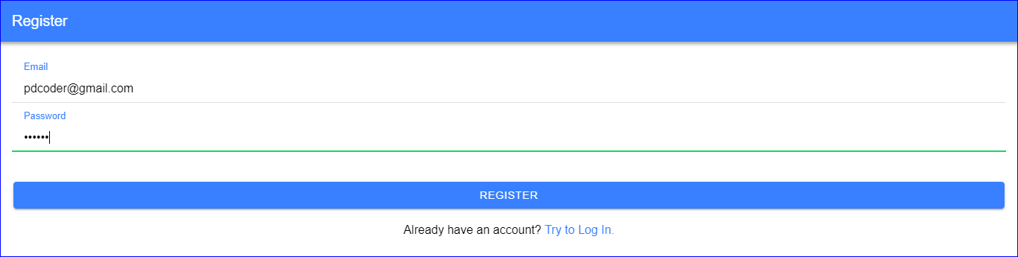

Registration page for users

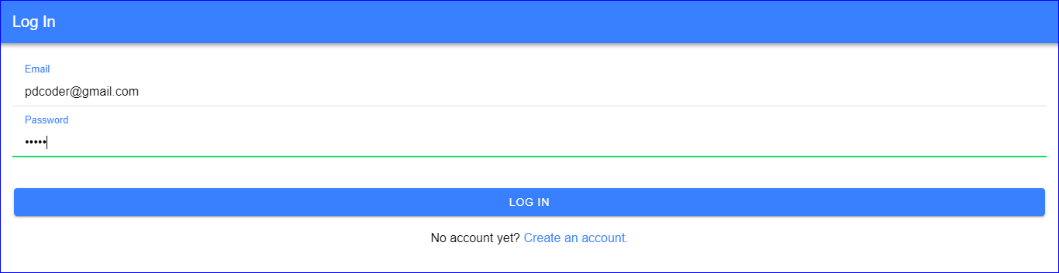

Log in page for users



Book image

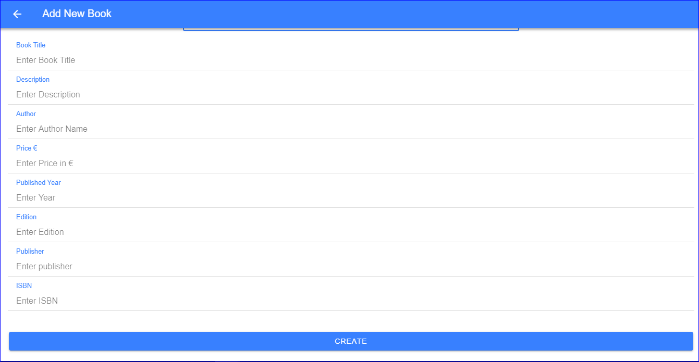

Page for creating a new book

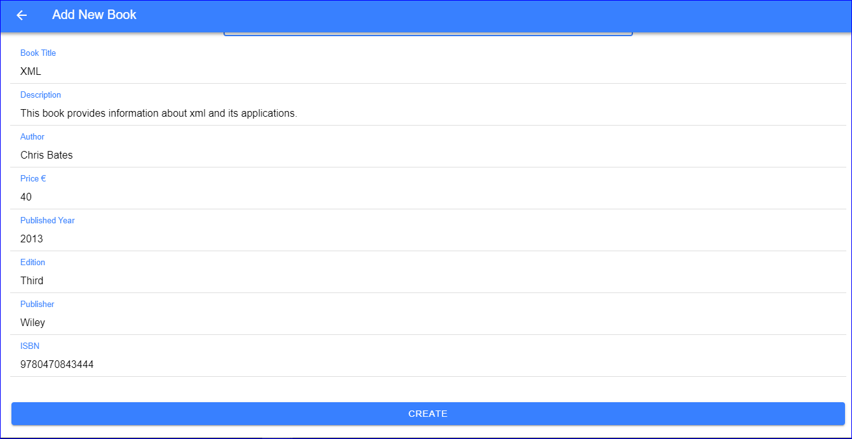

Entered details of the new book

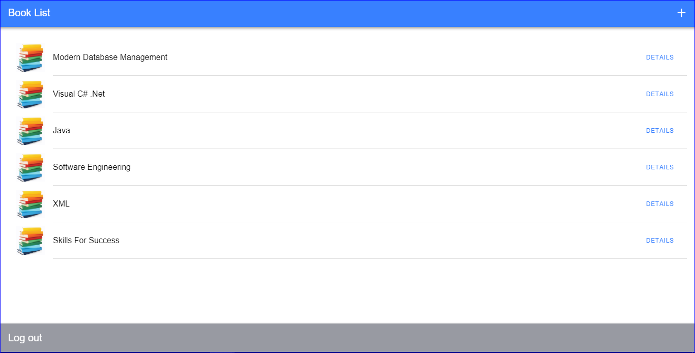

Book List Page

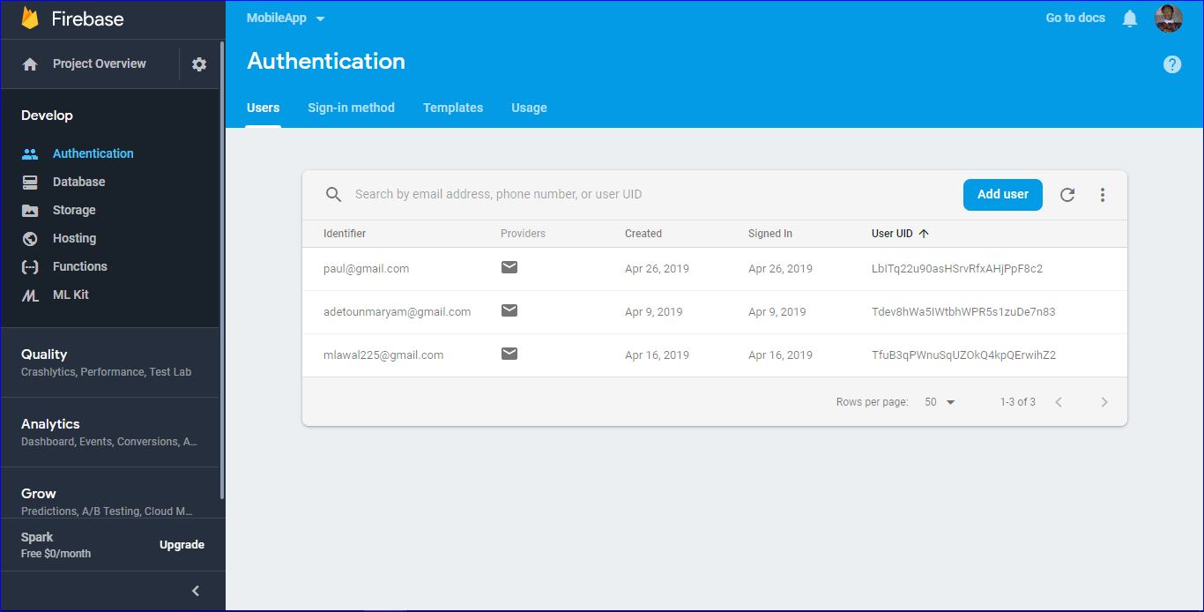

Authentication Page

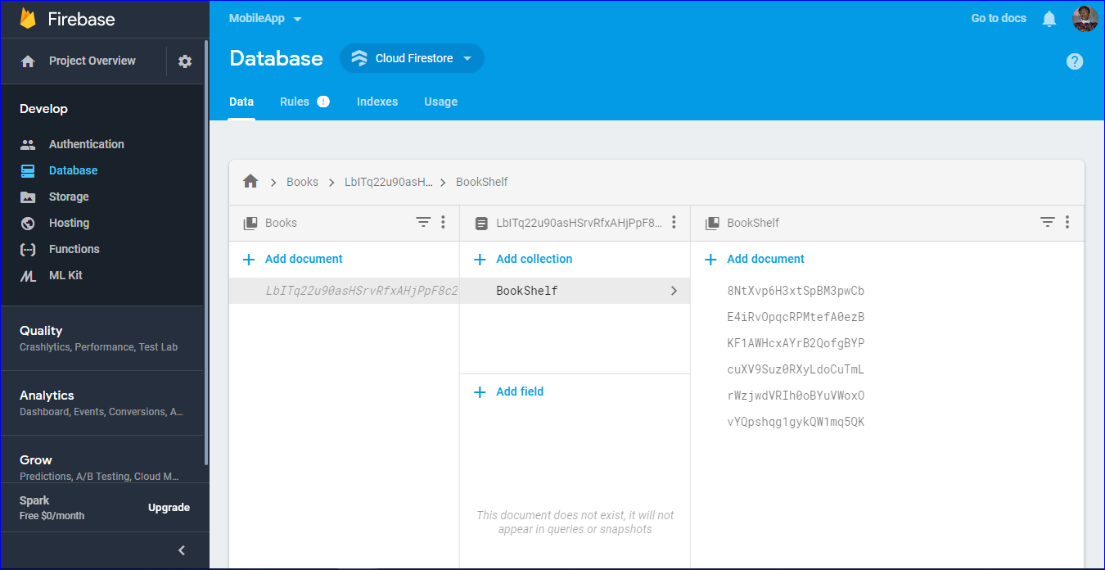

Database Page

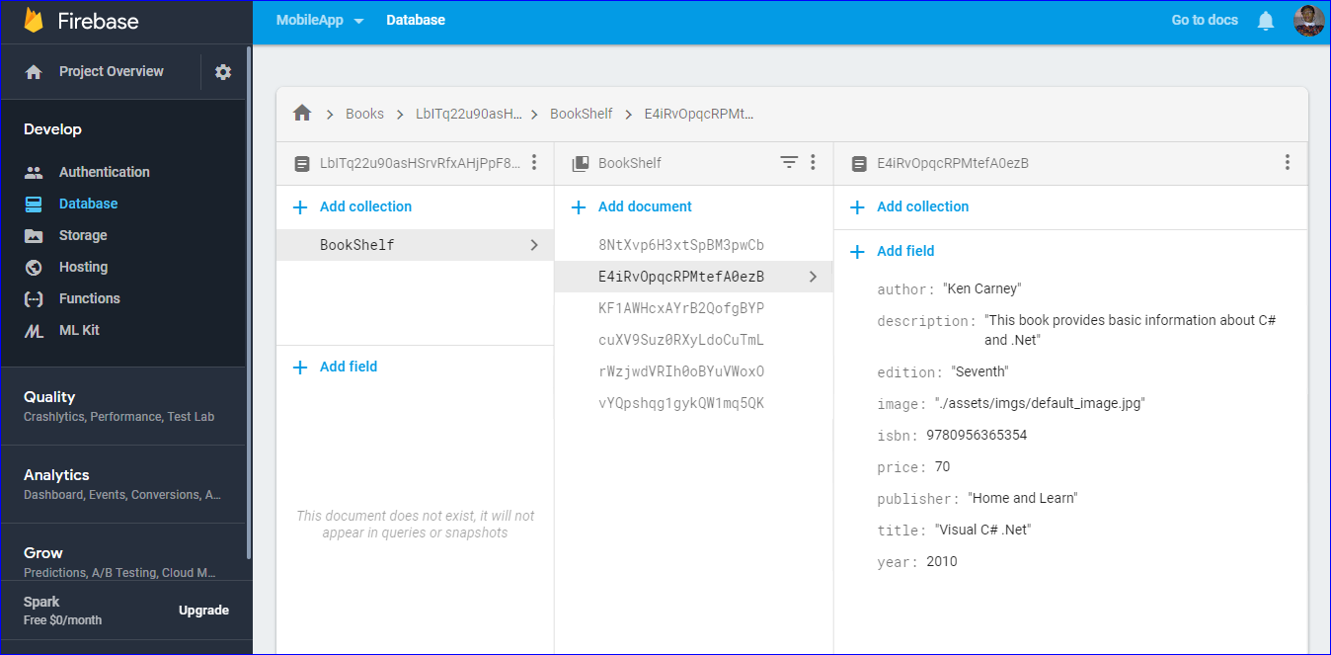

Database page with the details of the book

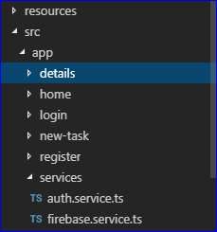

Package of pages added in the app

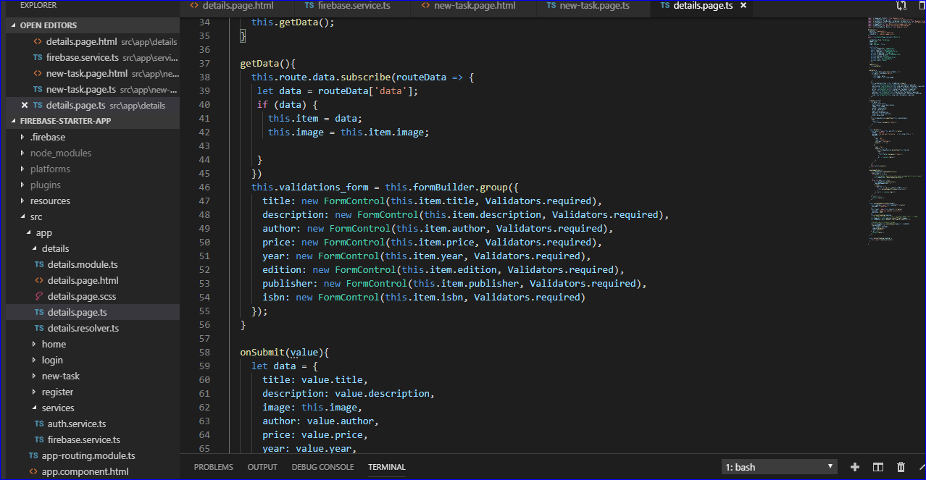

details page: get data and on submit method

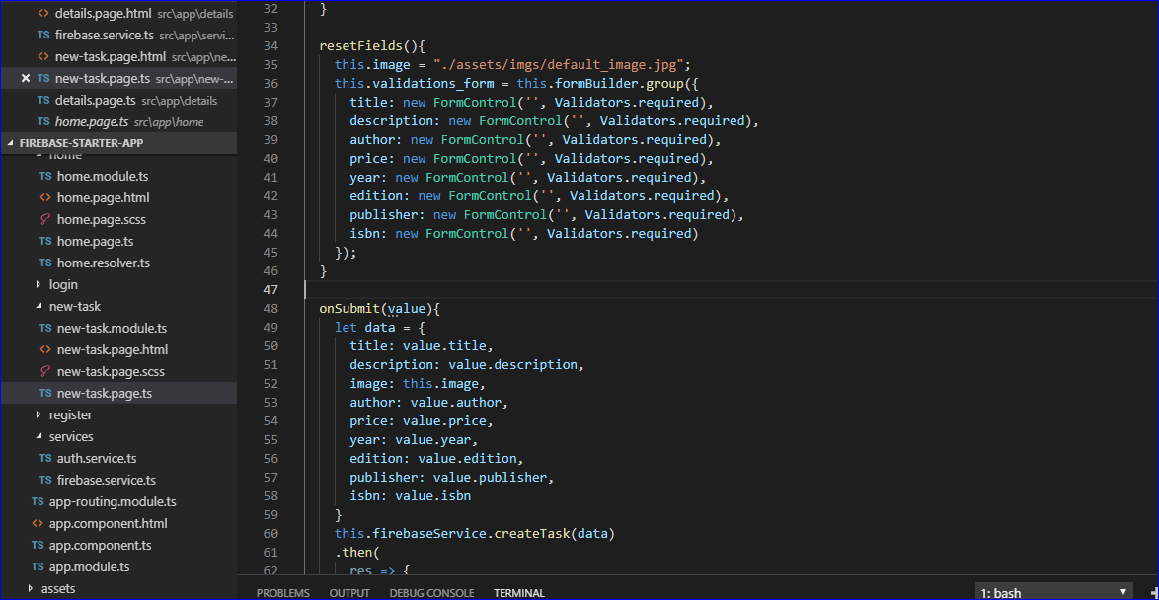

new task html: reset fields and on submit method

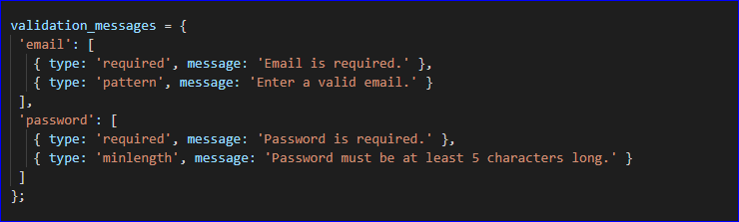

validation of the registration form

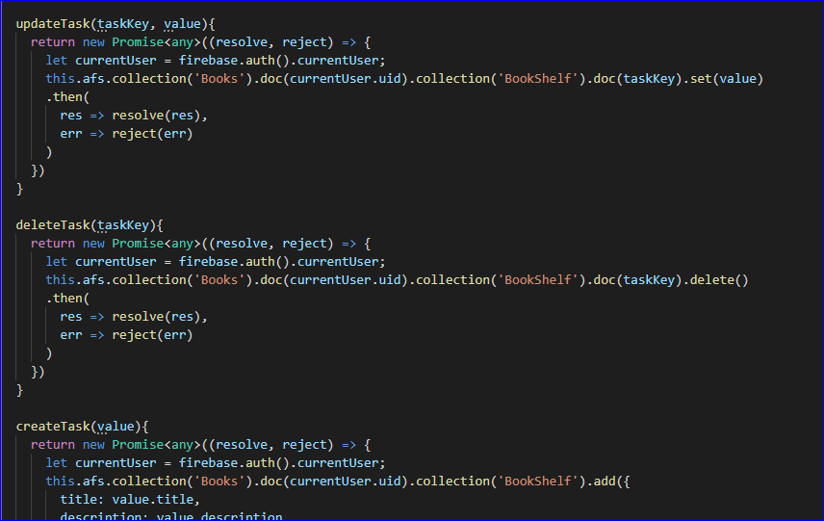

create update delete task methods in firebase service type script

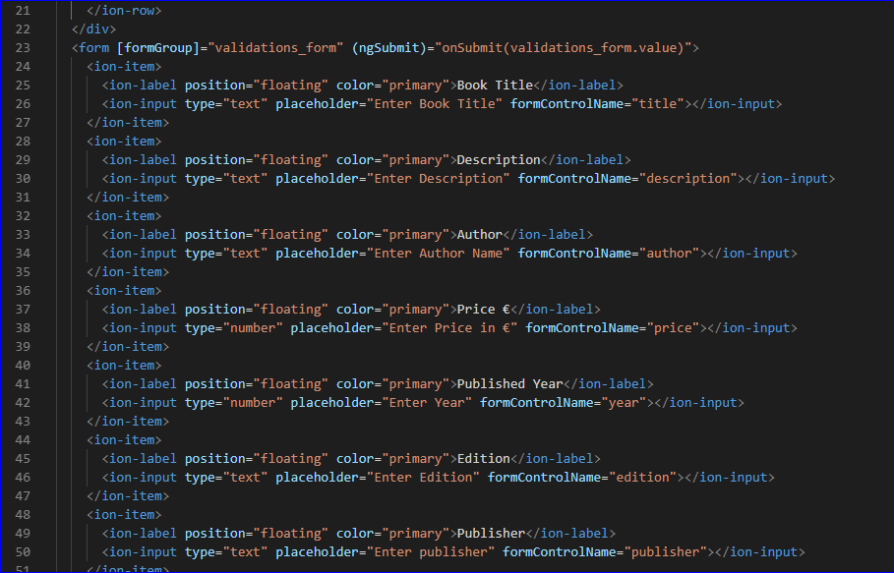

html page of new book list form

**CONCLUSION**

Working together on this project has been a good learning experience, here we created a Mobile Application where we are learnt to save data on Ionic Fire-Base framework. We also learnt how to, add functions using Ionic framework, installing and running Cordova and Ionic (npm install), run Ionic apps on sever and study visual code CLI and setting up Fire-Base platform with authentication and Database. We have implemented the project as per the requirements.